MAIN MENU FOR CONVENTION CENTER

SOME OF THE GOALS

* The database will allow the Convention Center staff to find out:
  + which Hall is booked the most and which one brigs the most revenue.
  + the most popular Meals and drinks utilized.
  + The most popular events and the ones that bring the most revenue
  + the hourly employees like waiters available to work for an event
  + the supplies used per event (tables, table clothes etc.)
  + the yearly profit
  + the electricity and water usage among other cost.

*An interesting business goal:*

The Convention’s Database captures how the customer contacted the center. In this way, the convention center can utilize such data to select the best method of advertisement to add more customer.

SELECTION 1: Selecting a Table

THE HALLS TABLE

SELECTION 2, 3: Update or Delete a Value or name from a table



SELECTION 4. Add a row to table

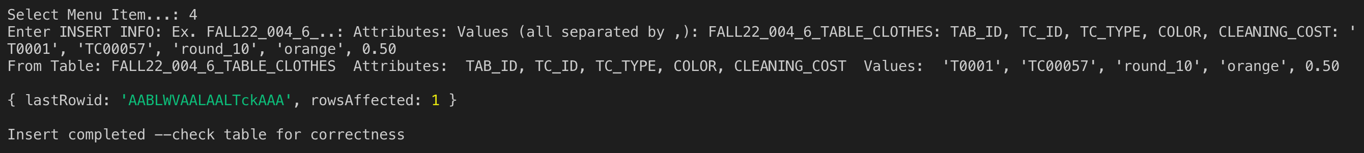

SELECTION 5. The top alcoholic or non alcoholic that the Center sells

SELECTION 6. TOP 10 MEALS THE CENTER SELLS

SELECTION 7. Information about a particular Event

SELECTION 8. Tables requires for Events

SELECTION 9. REVENUE FOR A PARTICULAR YEAR

SELECTION 10. FINACIALS FOR HALL AND EVENT (ROLL UP OR CUBE)

SELECTION 11. MOST BOOKED HALLS AND REVENUE

SELECTION 12. Employees available to work per type

SELECTION 13. WAYS CLIENTS CONTACT THE CENTER

SELECTION 14. COST OF UTILITIES –Water or Electricity per year

SELECTION 15 – QUIT

